
1251 East Wisconsin Avenue
Pewaukee, Wisconsin 53072-3755

Tel: 262-691-3320
Fax: 262-691-3008
Email: harken@harken.com
Web: www.harken.com

P R E S S R E L E A S E
I N O V A T I V E S A I L I N G S O L U T I O N S
I N N O V A T I V E S A I L I N G S O L U T I O N S
Contact: Bill Goggins FOR IMMEDIATE RELEASE
billg@harken.com
1.262.691.3320

Harken Radial Winches Break Through to the Next Level in Winch Design
All-New Line Largest Product Introduction in Company History

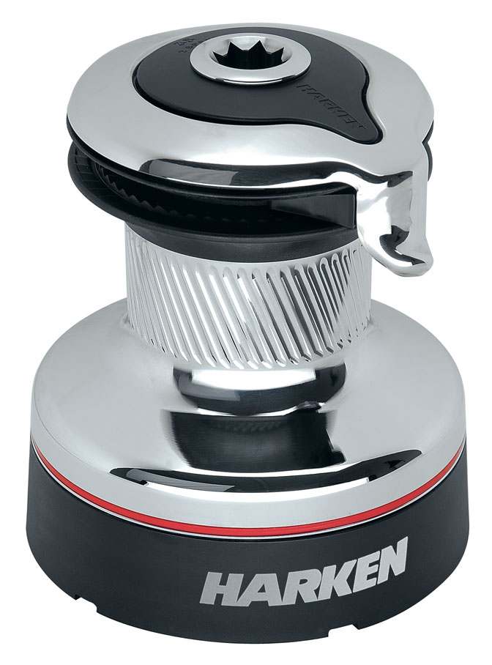

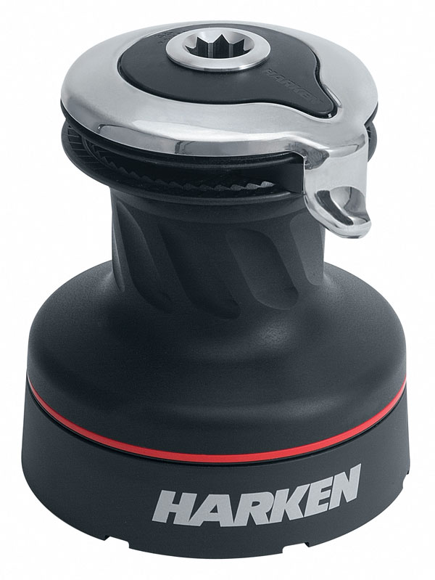

Pewaukee, WI—Winches haven’t seen changes like these in more than 20 years!
Combining advanced technology and materials with the creative minds of Harken Italy engineers, Harken’s Radial winch line is revolutionary and breaks through to the next level in winch design.
Details sailors will appreciate: weight reductions between 25 and 50 percent, allowing smaller winches to carry higher loads; shaped gripping surfaces for reduced line wear; stress-free seasonal maintenance, and one-person installation with easy upgrades to power.
“We designed Radial winches from the deck up with three key ideas in mind: safety and long-lasting performance, streamlined installations, and hydraulic and electric upgrades as integral parts of the design,” said Technical Director Andrea Merello. “This all-new winch line represents a continuation of Harken’s goal of providing sailors with innovative ground-breaking products that will enrich their sailing experience.”

When Sailors Think Winches, They Think Radial
The drum’s gripping surface is shaped for each winch size and drum material, and features diagonal ribs (rather than textured materials) to maximize gripping power and greatly reduce line wear. When easing, other winches tend to push the line wraps up. The Radial grip works more like a screw, driving the wraps down when easing to keep them on the part of the drum where you have the best control.
The strong, one-piece stripper arm completely covers the winch top. The top does not rotate, preventing fingers and clothing from catching in moving parts—an important safety feature, particularly when operating powered winches. The arm can be adjusted to multiple positions after the winch is mounted and is shaped to smoothly feed line into and out of the self-tailing jaws. Under line pressure, the spring-loaded upper jaw adjusts to accept a variety of line sizes.
— MORE —
Harken Radial Winches— continued
Strong, lightweight composite roller bearings and bushing (in sized 20 winches) have excellent corrosion resistance and don’t require lubrication. The snap-fit design keeps bearings captive in a high-strength, Delrin® cage when the drum is removed for maintenance. Load-carrying gears and pins are 17-4PH stainless steel.

Harken’s patent-pending stud-bolt mounting system allows one person to quickly install a winch through predrilled holes on deck—without removing the drum. Seasonal maintenance is also exceptionally easy. The drum lifts out as a single unit and roller bearings remain captive, making reassembly quick and mistake-free, with bearings lost overboard a thing of the past.

Part of the design goal for Radial winches was that they easily convert to power, with upgrades an integral part of the design, rather than added as an afterthought. There is no need for an adapter plate and the identical stud pattern means no filling old holes and drilling new ones. Boatbuilders can make upgrades even easier by precutting and sealing a 3.00 in (7.6 cm) drive-shaft hole into the boat.

Harken, Inc. is a leading manufacturer and distributor of innovative sailboat hardware and accessories. Headquartered in Pewaukee, Wisconsin, Harken manufactures in the USA and Italy. Its network includes offices in 48 countries, with group offices located in Australia, France, Italy, New Zealand, Poland, Slovenia, Sweden, the United Kingdom and the United States (Rhode Island, California, and Florida).

# # #

